1. **What is Postman?**

* Postman is a rest client software that started as a chrome extension but is now available as native application also.
* Postman is basically used for API testing in which you can test your APIs with different types of request method types like post, put etc. and parameters, headers and cookies.
* Apart from setting the query parameters and checking the response, postman also let us see different response stats like time, status, headers, cookies etc.

1. **What is an API?**

API stands for Application Programming Interface. APIs allow programmers to

interact with other software.

Example - It can be considered as the waiter which acts as the middleman between your requests and the chef. Similarly, API refers as the middleman between a client and a server.

Client Web Service API Server

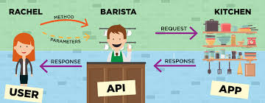

1. **What is Environment in Postman?**

* An environment in Postman is a set of key-value pairs.
* An environment provides boundaries to variables. When we create different environment, we can make track of all the variables and how to use them inside our requests
* You can create multiple env in postman

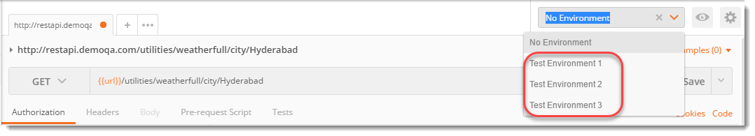

1. **How many types of Environment in Postman?**

There are two types of environment, global and local.

1. ***What is an Environment Variable in Postman?***

A variable is an entity whose value can be changed. **The key part in the key-value set in environment is called variable**. This variable can have any value and in place of the **key** we can use the variable name in every request

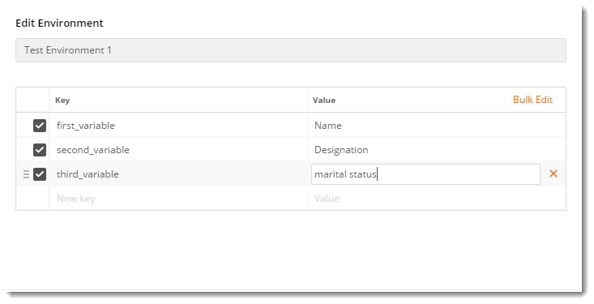

1. **Can we have two global scope variables with the same name in Postman?**

NO - Since global variables are global i.e. without any environment, they cannot have duplicate names as it creates confusion for the software.

Local variables can have same name but in different environments.

1. **Which one has the higher priority in Postman? A global variable or a local variable?**

* In Postman, if two variables have same name (**one being local and one being global**) then the higher priority is of the local variable. It will overwrite the global variable.

1. **Explain the following piece of test code in Postman**

tests[“Status Code is 200”] = responseCode.code === 200

* tests – variable on one of type array
* Status code is 200 – A string or the test name which will be represented in the test result box so that we can know what test was it. It is important as we use many tests on one request.
* responseCode.code = responseCode is used to save all the response that we get from the server. Since we do not need complete response, we need to create one object to extract our required info. code object is then called to output the status code (like 200) from the entire response which we have saved.

1. **What is Postman collection?**

A Postman Collection is a suite which lets you group individual requests together. Requests can be organized into folders. Below snapshot shows how we can create a collection:

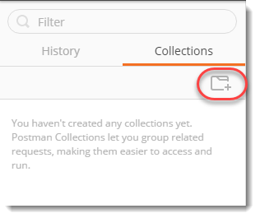

Some of the operations users can perform on collection - Add/create collections, edit collections, delete collections, share collections, export collections, duplicate (or copy) a collection.

1. **What are tests in Postman? Explain**

A TEST in Postman is similar to the definition of test in general. IN Postman, we test the response received from the server

Important points:

* A test does not run always. **A test runs only when the request was successful**. If your request was not correct, we cannot run tests through it.
* Tests are written in Javascript in Postman.

1. **How test can be written in Postman?**

TEST in postman can be written in two ways, namely

* Javascript method
* Functional method

JavaScript method is the older method whereas functional method is the new method. both the methods uses javascript as the base language.

It recommends to use the functional method and as it says on the official website of Postman, “**Functional method is the more powerful method among the two**“.

Steps to create test:

Create a POST request

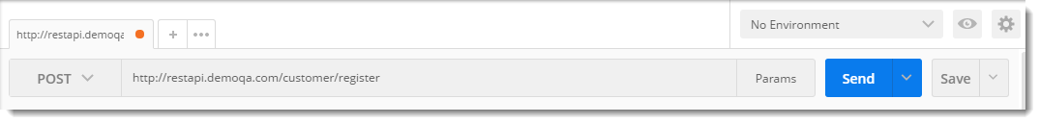

Go to Tests tab

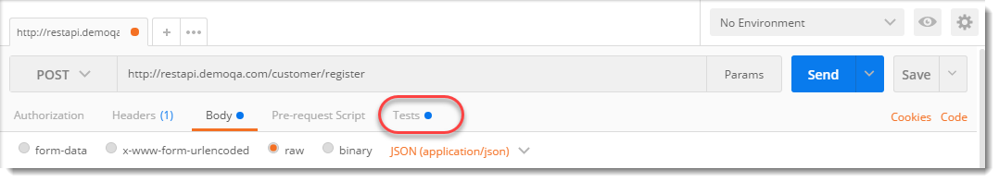

Write the javascript code (single test)

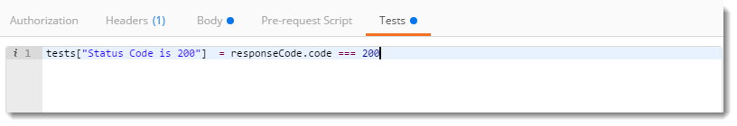

Setup multiple tests

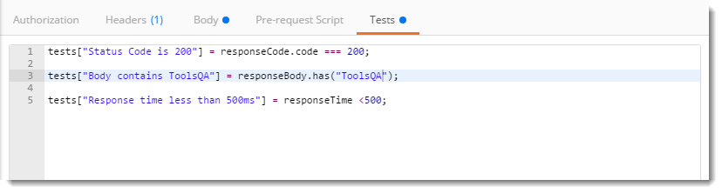

1. How to set Tests using Functional Method in Postman?

A simple functional method of ***testing whether the status code is 200*** is written below

*pm.test(“Status code is 200”, function () {*  
*pm.response.to.have.status(200);*  
*});*

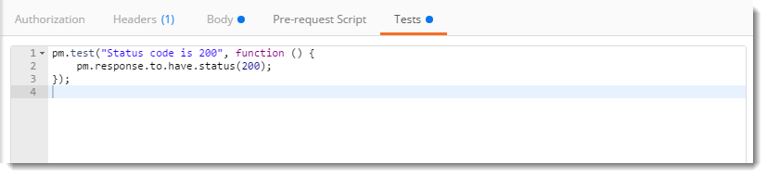

* **pm.test** : **pm** here refers to Postman api and **test** refers to the specification of the function
* **Status code is 200 :**This line is just a string which is the **test name**. When your test is performed this String will be written in front of the result.
* **function(){} :**The next parameter is the function which is passed to perform the test
* **pm.response :**This is used to capture the response received and perform assertions on it such as status code, headers etc.

1. **What is Collection Runner in Postman?**

A collection runner runs all the requests in the collection or folder (whatever you choose) at once. Collection runner does not show any response, it is used to check the test cases whether they passed or not. A collection runner console shows all the tests at one location and their result. To run collection runner first make sure you have at least two requests in the folder

1. How to run Collection Runner in Postman

1.Click on ***Runner***

[](http://toolsqa.com/wp-content/uploads/sites/1/nggallery/postman/Runner.png)

2. Click on ***Collection*** and then ***Folder.*** Specify the **iteration** and **delay** in between each iteration.

[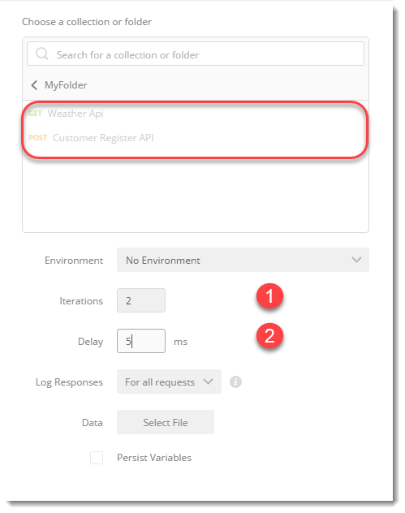](http://toolsqa.com/wp-content/uploads/sites/1/nggallery/postman/Select_Collection_In_Runner2.png)

Iterations : An iteration number is the number of times the same requests will run.

Delay : A delay time is the time to wait between any two iterations.

1. **What are Postman monitors?**

Monitors schedule a Collection of test runs to monitor the performance and Response of your APIs. Monitors can be scheduled to run very frequently, like every 5 minutes, or can be scheduled to run at an interval of few hours throughout the day.

1. **What is a Cookie?**

Cookie in simpler terms means just the textual information saved by some website. When you visit a particular website, some information is saved in your local system so that when you visit the same website again, this website is able to recognize you and show you the results according to your preferences.

1. **How do we manage cookie in Postman?**

Postman provides a ***Cookie Manager*** separately where you can ***Add, Delete or Modify the Cookies***.

Click “***Cookies***” on the top right.

[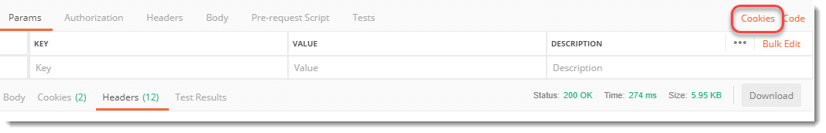](http://toolsqa.com/wp-content/uploads/sites/1/nggallery/postman/Cookie_Manager.png)

This will open the cookie manager panel where you can see all the cookies are located.

[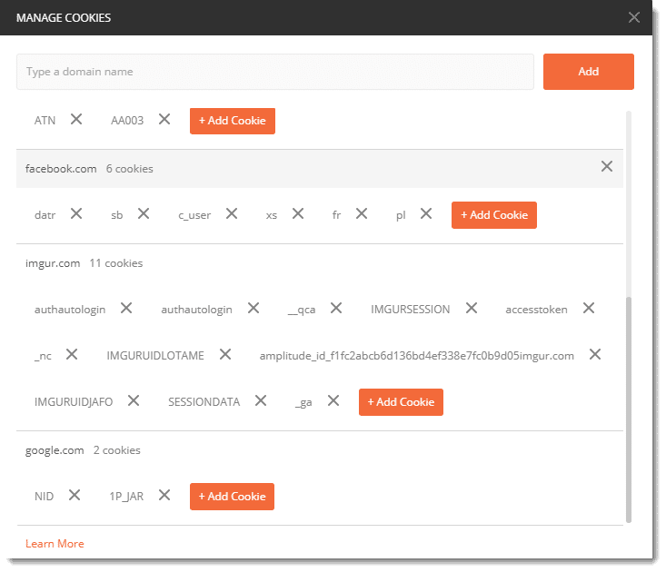](http://toolsqa.com/wp-content/uploads/sites/1/nggallery/postman/Cookie_Manager-2.png)

You can add cookie by clicking on “Add Cookie” button. Similarly, you can delete cookie by clicking on “X” icon next to the cookie name

Sample code to check if cookie exists or not

pm.test(“Cookies_Check”, function(){  
pm.expect(pm.cookies.has(‘NID’)).to.be.true;  
});

NID is the name of the cookie (in the last row of the above snapshot)

[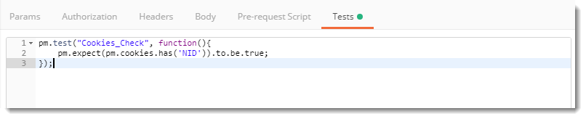](http://toolsqa.com/wp-content/uploads/sites/1/nggallery/postman/Check_Cookie_Availability.png)

1. **Describe any four response things you receive from a response**

* Status Code
* Response Status
* Response time
* Response Size
* Response Headers
* Response Cookies
* Response Date and Time
* Response Session limit
* Response Cookies
* Response Server
* Response type

1. **Should we save our work in Postman cloud if we are working in a company?**

* A Postman cloud is Postman company’s repository like Microsoft has One Drive etc.
* In Postman cloud you can save your work instantly after logging in and also retrieve it from anywhere you want.
* It is **not preferred** to save your work in Postman cloud as company’s work is often confidential and should not be leaked out.

1. **State 4 heavily used types of Request Method types.**

* Get
* Post
* Put, and
* Delete

1. **Define status code 401. Also, a situation in which we can incur such status code.**

* Status code 401 is referred for an unauthorized request. An unauthorized request is a request for which you are not authorized. We can incur such a status code when you are not authorized to access the server or you have entered wrong credentials.

1. **What are different types by which we can see response body in Postman.**

* In Postman, a response body can be seen by three different types
  + Pretty
  + Raw
  + Preview

Although all the three have their own importance and value in Postman, the most commonly used is Pretty as it shows the response code in different format and colors which is easy to read and analyze the response

1. **What is Pre-Request Script in Postman?**

* A pre request script is a script that runs before the execution of a request.

1. **What is the difference between authorization and authentication?**

* Authentication is a process of presenting your credentials to the system and the system validating your credentials. These credentials tell the system about who you are.
* Authorization is a process of allowing or denying someone from accessing something, once authentication is done.